**Working of the complete project**

**Name :- Pavneet Kaur**

**Backend Technology: Node JS ,Express Js**

**Database : MongoDB**

**Template :Ejs**

**Modules : Nexmo**

The main page has three navigation bar containing three tabs:-

1. Home (page itself)
2. Contact List (This is the first tab as mentioned in the requirement list)
3. Sent Messages (This contains the list of users to which OTP is send in sorting order of time).

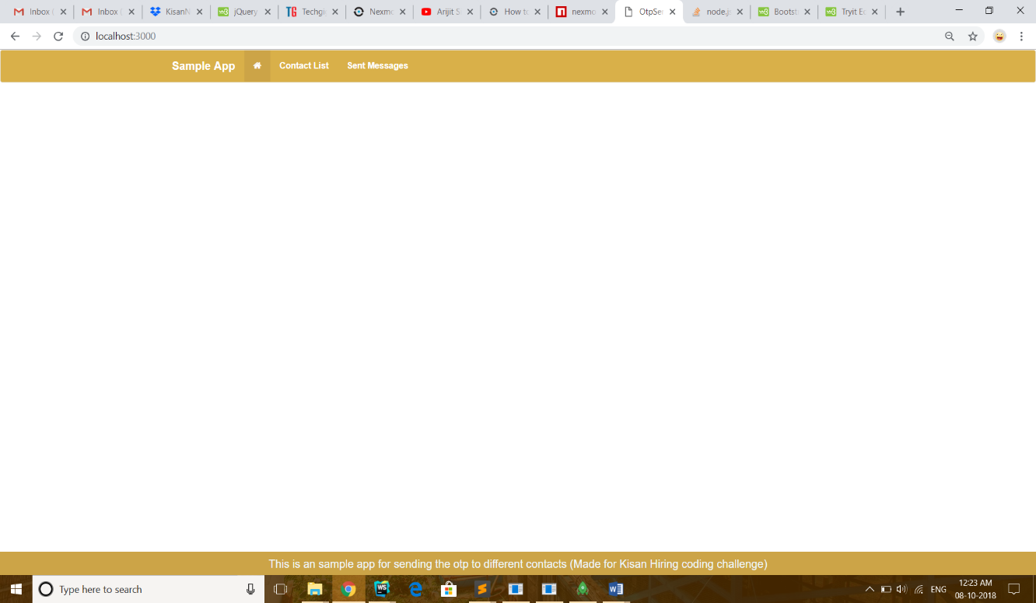

On clicking the contact list tab the following list appears: -

The list.json file is included in the documents which contains all the information i.e. first name, last name and contact number.

I have created a database using mongoose named **otpsendapp** and inserted this list.json in the database and retrieved this names of users from the list.

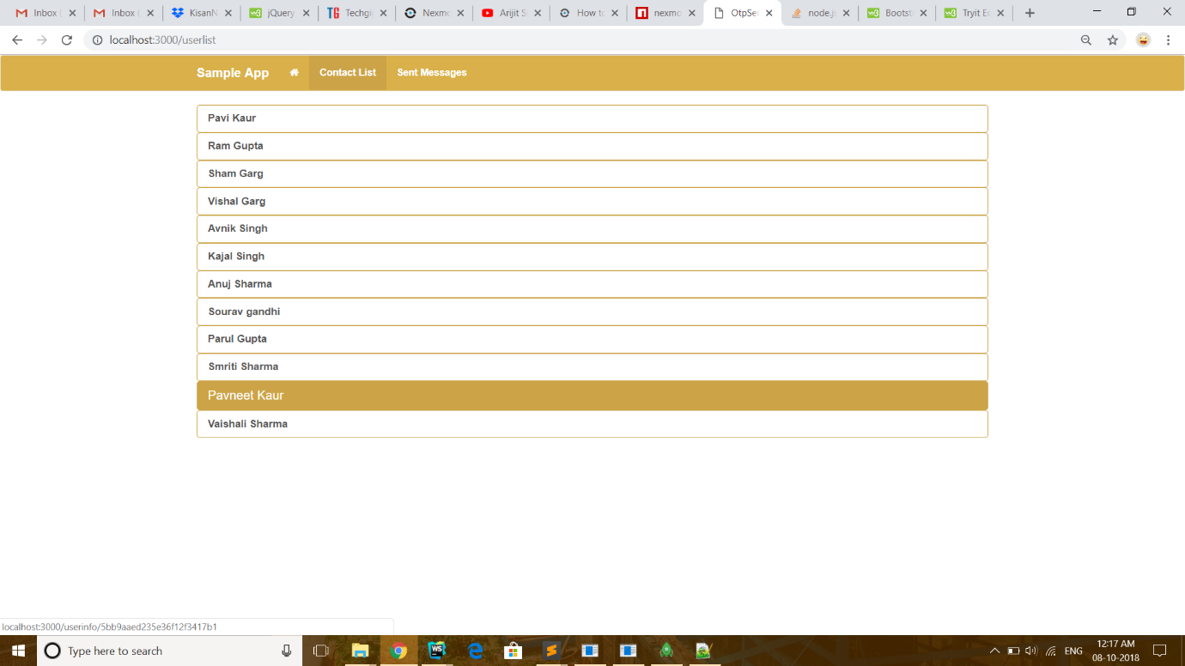

On clicking any of the name the following userdetails page will be opened: -

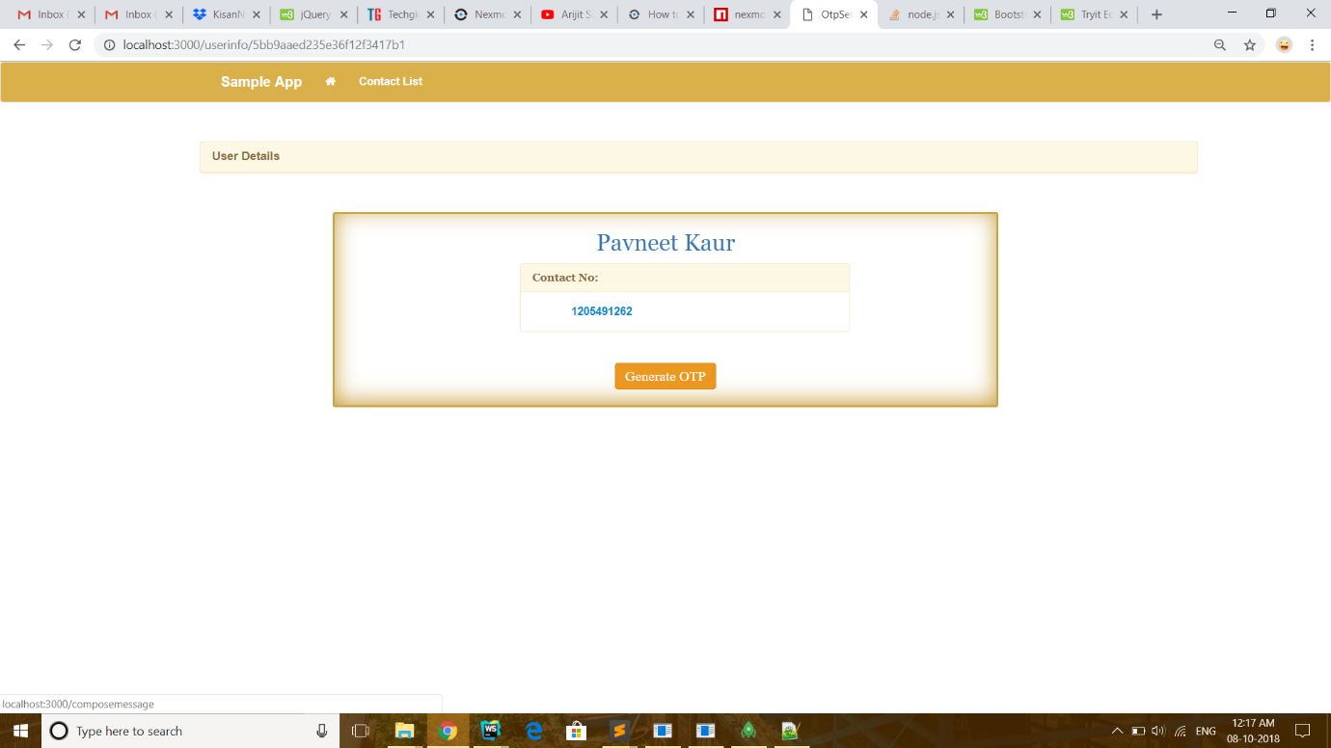

On clicking Generate OTP following page will be opened:-

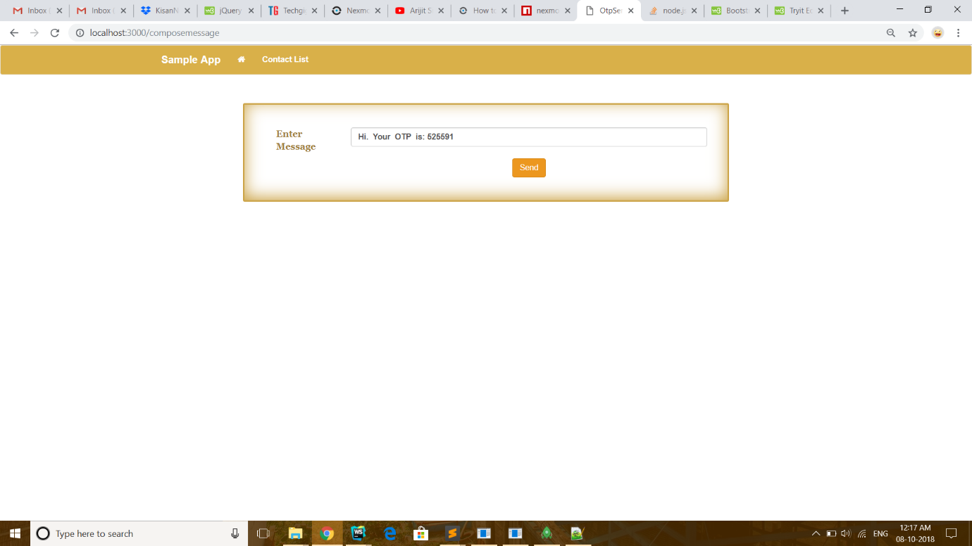

Here, The message is composed from backend with generating **a six digit random number**.

On clicking Send button, message is sent.

I have used **nexmo** module for sending the message. But ,only test numbers that can be added are send messages else it is paid service. Those numbers need two factor verification as well .I can send the message to mentioned number in requirement document but for that it is need to be verified.(You can contact me for that.).

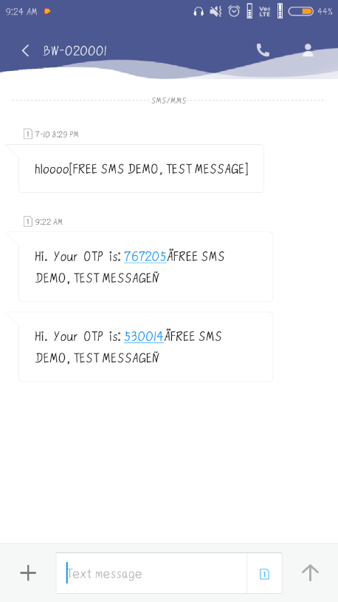

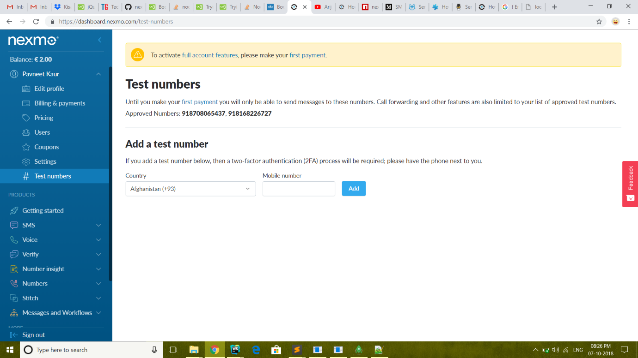

In the fig below I used my registered number and I received the message.

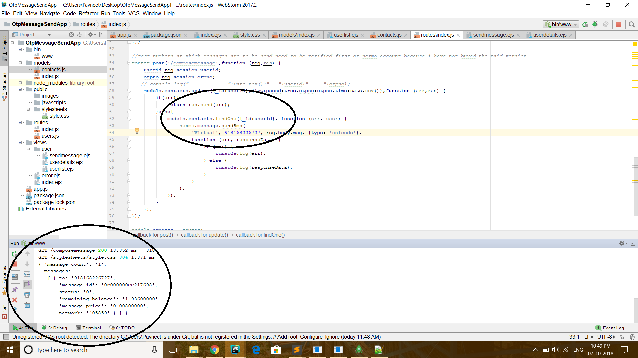

If the number is not registered it is displayed that destination is not defined.

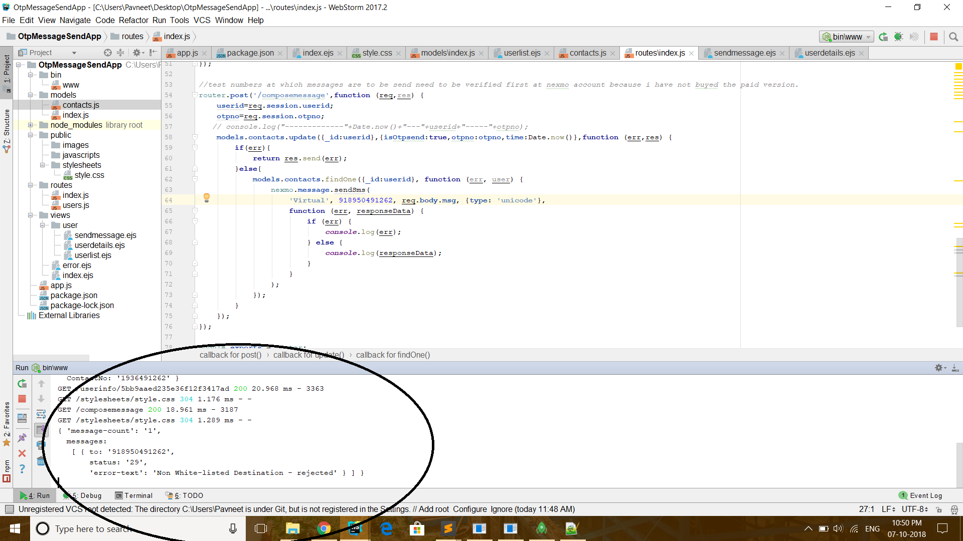

But if paid access of nexmo is taken it will work fine.

On clicking the Send Messages tab ( 2nd tab required) , the following details of user is shown:-

The list is displayed in sorted order of the messages sent.

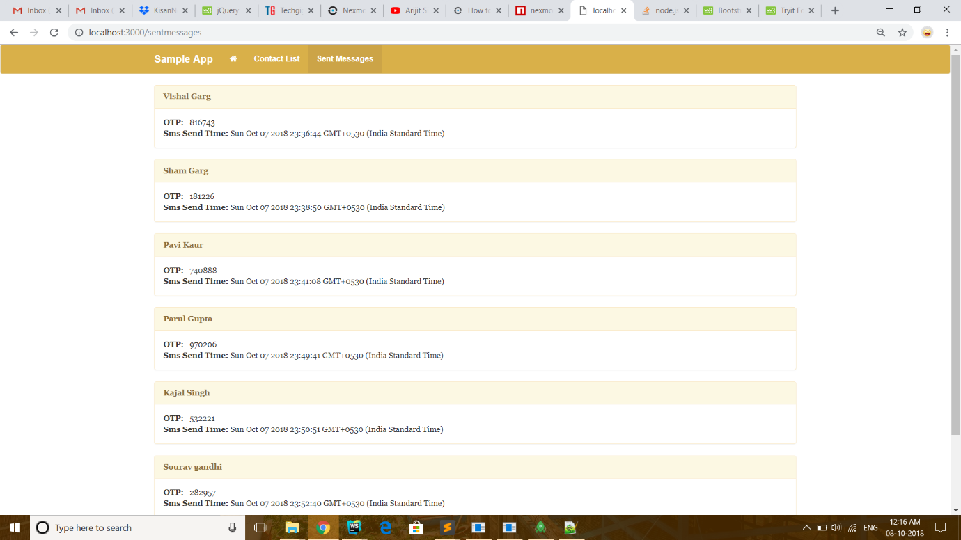

The whole project is also present at **github** repository: -https://github.com/pavneetkaur27/otpsendapp

The site is also hosted at **Heroku** platform with name: - <https://otpsendapp.herokuapp.com/>

But it will not completely work their because Heroku charge for database services like mongoose etc. I have not created database because sites like mlab on connecting with Heroku are needed to be paid.

The website is **responsive** as well:-

